**1.2 image**

**Class _____________ name______________**

1. A touch screen has three squares where a selection can be made:

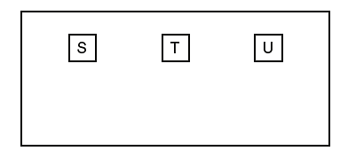

* 1. The x-coordinate of the centre of the three squares is held in three memory locations:

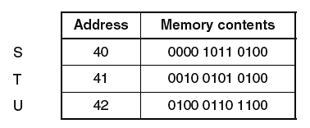

* + 1. Give the hexadecimal value of the memory contents for U.
    2. Convert the denary number 40 into binary.
  1. Bitmap graphics are used to represent squares S, T and U. These can be saved in a number of different image resolutions.
     1. Give the number of bits required to store each pixel for a black and white bitmap.
     2. Identify how many bits are required to store each pixel for a 256-colour bitmap. Explain your answer.

1. A company is designing a website.
   1. The company creates a 4-colour bitmap image for the website as shown. Each colour is represented by a letter, for example, G = grey, K = black.

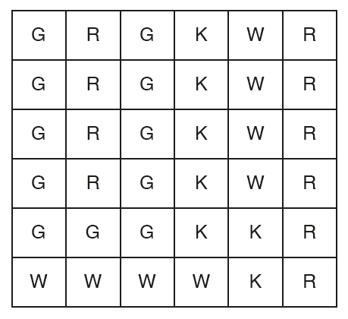

* + 1. State the minimum number of bits needed to represent each pixel in the image in **part (a)**.
    2. Calculate the minimum file size of the image shown in **part (a)**. Show your working.

Working:

File size:

* 1. The company takes a photograph of their office to put on the website. The photograph has a resolution of 1000 pixels by 1000 pixels. Two bytes per pixel are used to represent the colours.
     1. Estimate the file size of the photograph in megabytes. Show your working.

Working:

Estimated file size:

* 1. The company has created a logo for the website. The logo is a vector graphic. Describe **two** reasons why a vector graphic is a sensible choice for the logo.

Reason 1:

Reason 2:

1. A logo is designed as a bitmap image.
   1. Describe what is meant by a **bitmap image**.
   2. A bitmap image is shown.



* + 1. Explain how a computer can store this bitmap image.
  1. The finished logo is 500 pixels by 1000 pixels and uses 2563 different colours. Estimate the file size for the logo. Give your answer in kilobytes. Show your working.
  2. The actual bitmap file size will be larger than your calculated value as a bitmap file has a file header. State the purpose of the file header. Give two examples of the file header contents.

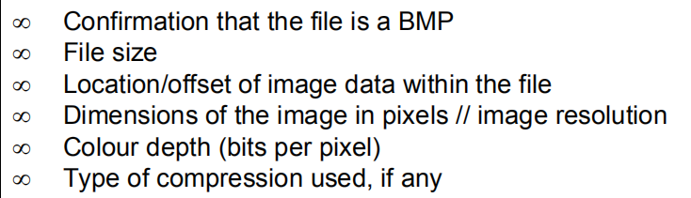

* 1. The logo is redesigned as a vector graphic. State **two** benefits of a vector graphic compared to a bitmap image. Give a reason for each benefit.
  2. Graphics software is used to edit a digital photograph. Give **three** features of graphics software that can be used to edit the photograph. Describe the effect each has on the photograph.

Feature 1

Effect 1

Feature 2

Effect 1

Feature 3

Effect

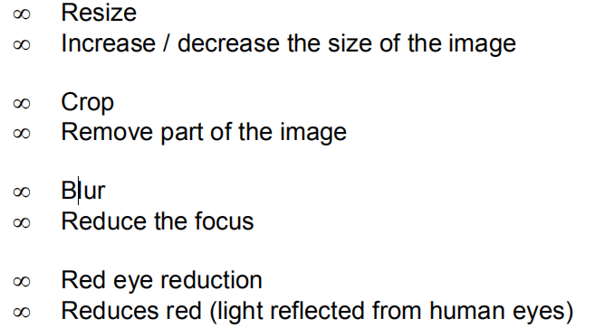

* 1. Six computer graphics terms and seven descriptions are shown below. Draw a line to link each term to its correct description.

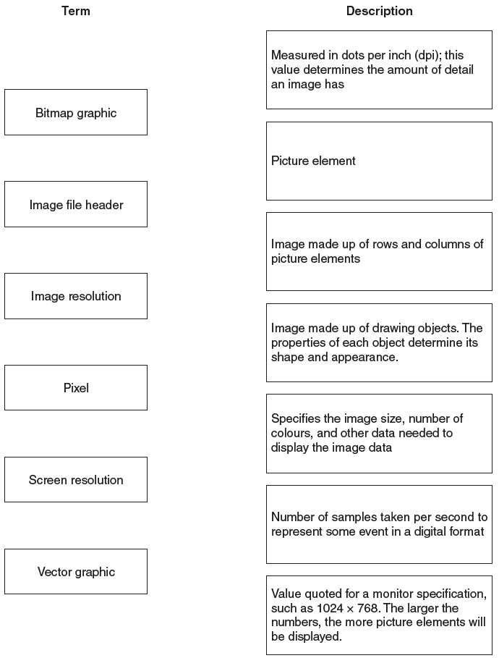

* + 1. A black and white image is 512 pixels by 256 pixels. Calculate the file size of this image in kilobytes (KB) (1 KB = 1024 bytes). Show your working.
    2. Give a reason why it is important to estimate the file size of an image.

1. Explain the following terms:
   1. Drawing object
   2. Screen resolution
   3. Pixel
   4. Image resolution
2. The designer is concerned about the size of some bitmap files, if the resolution is to be 640*480 and the colour depth is to be 24 bit, calculate the size for the bitmap.
3. Give four differences between bitmap and vector graphics.